|  |  |
| --- | --- |
| Experiment Number:04 | **04** |
| **Title: Performing an Initial Switch Configuration using cisco packet tracer.** |
| ▪ |  |

**Second Year Advanced Computer Networking**

**Theory:-**

**Topology**

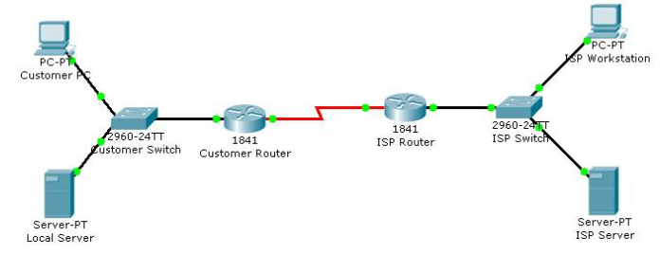

**Objectives**

• Perform an initial configuration of a Cisco Catalyst 2960 switch.

**Background / Preparation**

In this activity, you will configure these settings on the customer Cisco Catalyst 2960 switch:

* Host name Console password
* vty password
* Privileged EXEC mode password
* Privileged EXEC mode secret
* IP address on VLAN1 interface
* Default gateway

**Step 1: Configure the switch host name.**

a. From the Customer PC, use a console cable and terminal emulation software to connect to the console

of the customer Cisco Catalyst 2960 switch.

b. Set the host name on the switch to CustomerSwitch using these commands.

Switch>enable

Switch#configure terminal

Switch(config)#hostname CustomerSwitch

**Step 2: Configure the privileged mode password and secret.**

a. From global configuration mode, configure the password as cisco. CustomerSwitch(config)#enable password cisco

b. From global configuration mode, configure the secret as cisco123. CustomerSwitch(config)#enable secret cisco123

**Step 3: Configure the console password.**

a. From global configuration mode, switch to configuration mode to configure the console line.

CustomerSwitch(config)#line console 0

b. From line configuration mode, set the password to cisco and require the password to be entered at

login.

CustomerSwitch(config-line)#password cisco

CustomerSwitch(config-line)#login

CustomerSwitch(config-line)#exit

**Step 4: Configure the vty password.**

a. From global configuration mode, switch to the configuration mode for the vty lines 0 through 15.

CustomerSwitch(config)#line vty 0 15

b. From line configuration mode, set the password to cisco and require the password to be entered at

login.

CustomerSwitch(config-line)#password cisco

CustomerSwitch(config-line)#login

CustomerSwitch(config-line)#exit

**Step 5: Configure an IP address on interface VLAN1.**

From global configuration mode, switch to interface configuration mode for VLAN1, and assign the IP address

192.168.1.5 with the subnet mask of 255.255.255.0.

CustomerSwitch(config)#interface vlan 1

CustomerSwitch(config-if)#ip address 192.168.1.5 255.255.255.0

CustomerSwitch(config-if)#no shutdown

CustomerSwitch(config-if)#exit

**Step 6: Configure the default gateway.**

a. From global configuration mode, assign the default gateway to 192.168.1.1.

CustomerSwitch(config)#ip default-gateway 192.168.1.1

b. Click the Check Results button at the bottom of this instruction window to check your work.

**Step 7: Verify the configuration.**

The Customer Switch should now be able to ping the ISP Server at 209.165.201.10. The first one or two pings

may fail while ARP converges.

CustomerSwitch(config)#end

CustomerSwitch#ping 209.165.201.10

Type escape sequence to abort.

Sending 5, 100-byte ICMP Echos to 209.165.201.10, timeout is 2 seconds:

..!!!

Success rate is 60 percent (3/5), round-trip min/avg/max = 181/189/197 ms

CustomerSwitch#

Reflection

a. What is the significance of assigning the IP address to the VLAN1 interface instead of any of the Fast

Ethernet interfaces?

b. What command is necessary to enforce password authentication on the console and vty lines?

c. How many gigabit ports are available on the Cisco Catalyst 2960 switch that you used in the activity?